**Manish Kumar Mandal 29th July 2024**

**Emp. ID:- PS100036/51**

TO WHOMSOEVER IT MAY CONCERN

This is to certify that Manish Kumar Mandal Sri Kodi was working with **Precesion Staffing** from 5th January 2023 – 26th July 2024

The designation held by his at the time of leaving was US IT RECRUITER.

His brief experience summary during the stay with the organization is given below:

* Manage the entire life cycle of the recruitment process for clients in the US.
* Work closely with the Recruiting leads and hiring managers.
* Work on strategic global hiring programs.
* Develop an action plan for recruiting the best fit for the organization.
* Procure people for different IT Requirements.
* Use niche platforms related to IT, to source potential candidates.
* Personally conduct interviews, document the same, and report as the need arises.

During this tenure we found his performance and conduct to be satisfactory. We wish him the very best in her future endeavors

This letter is issued on the request of the employee

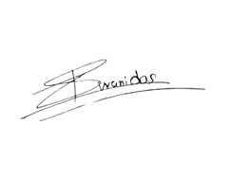

**Yours truly,**

(Authorized Signatory)

Shivani Das

Human Resources-Manager